Order Of Service

Singing: Psalm 46—CW page 84

Reading: Daniel 9

Opening Hymn: TLH 317

Reading: Daniel 9

Request Hymn: CW Supplement 735

Reading: Daniel 9

Sermon Hymn: TLH 326

Sermon Text: Daniel 9

A Prayer Of Repentance

Prayer

The Apostles’ Creed, TLH page 12

Holy Communion

The Lord's Prayer

The Blessing

Closing Hymn: TLH 644

* * * * * * * * * * *
Bible Study: Lambs: Elephant
Sheep: Romans 14:1-12
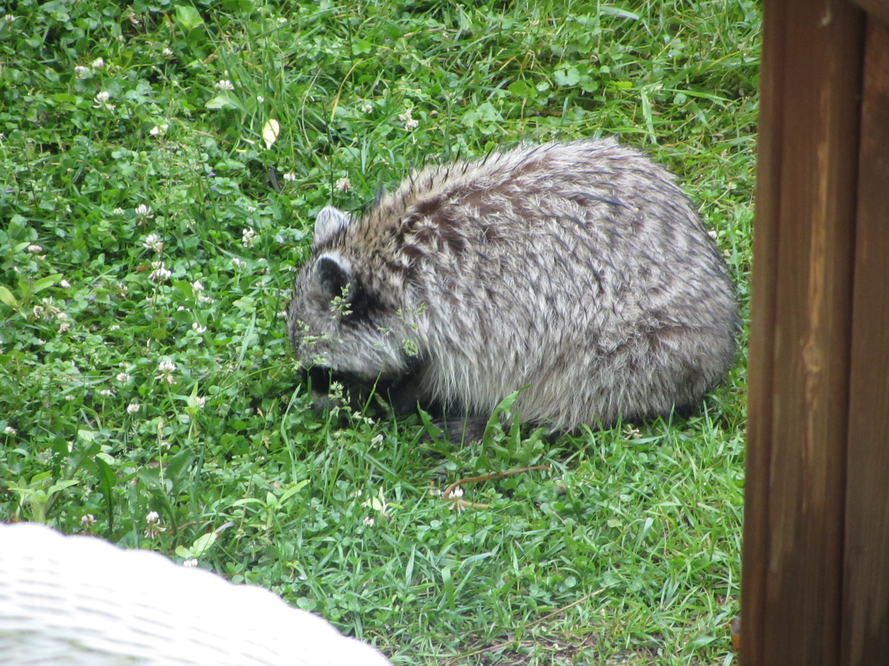

Feeding The Birds

Water
Of
Life

29 July 2018

W A T E R O F L I F E

Independent Christian Church—Conservative Lutheran Doctrine

Worship Service: 9:30 a.m. Bible Study: 10:45 a.m.

Larry Cooper, Pastor E-Mail address:
111 N. Ridge Road lcooper@wateroflife.cc
Coon Valley, WI 54623 Web Site:
Phone: (608) 452-2105 www.wateroflife.cc

* * * * * * * * * * * * * * * * * * * * * * * * * * *

Sermon Text: Daniel 9

A Prayer Of Repentance

* * * * * * * * * * * * * * * * * * * * * * * * * * *

The Willow Harps

Psalms 137:1 By the rivers of Babylon, there we sat down, yea, we wept, when we remembered Zion.
:2 We hanged our harps upon the willows in the midst thereof.
:3 For there they that carried us away captive required of us a song; and they that wasted us required of us mirth, saying, Sing us one of the songs of Zion.
:4 How shall we sing the LORD'S song in a strange land?

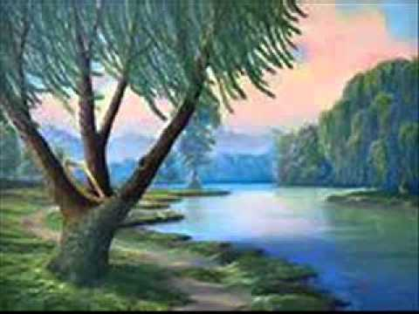

The Babylon captivity was now over for God’s people. Now the harps could be taken off the willow trees, and Israel could sing God’s praises again. But first—repentance.

